COMM13729 The Art Of Technical Communication  
Writing Reports

short line

“Clear, succinct, and accurate technical writing is an essential aspect of every project and can be the fundamental difference between success and failure. Others judge our capabilities by the way we present information, and poor writing signals incompetence.”  *(Ewald, p.76)*

Planning to write

Forethought, shape, and polish

Freewriting

Five Steps to Better Writing

Informal And Formal Reports

Find A Format and Make it Visible

Factors in Successful Reports

Content

Clarity

Skim-ability

Use a Visual Layout to Help the Eye of the Reader

Report Structure

Summary

Context

Details

Conclusion

Paragraphs

# Planning to write

## Forethought, shape, and polish

1. **Prewriting**: assessing the purpose, audience, and most appropriate channel for the communication.
2. **Organizing and outlining**: mapping out the most strategic and logical arrangement of ideas and details.
3. **Drafting**: composing the actual message by choosing the precise wording and the style of organization that delivers information most strategically.
4. **Revising and editing**: evaluating your draft from the point of view of your readers to check for completeness, coherence, accuracy, consistency, conciseness and appropriateness of language, and organization. Revising and editing represent a last chance for improvement.

### 

## Freewriting

If you are stuck, try [freewriting](https://docs.google.com/document/d/1JI80Sx6U3KoJK8iAQ_2vGxy0nYNwVJri3X-8tsjAG0g/edit?usp=sharing).

## Five Steps to Better Writing

Why follow steps in writing? A logical sequence assists the writer in organization and execution. This saves time for you and your intended readers. These five steps become a checklist so that you can do it right the first time.

STEP ONE.   
Start off quickly when the need arises to put something in writing. Procrastination prevents most writers from getting a document written. Review your purpose. Know why you are writing. Ask yourself: what am I trying to do with this document or letter? Know your readers. What are their concerns? What is their role? How can they assist or block your efforts? Collect and analyze any needed information. It is tempting to delay writing by claiming that more information is needed. Resist this temptation. Ask yourself: who can help me find what I need? where can I go to find it myself? Finally, outline your thoughts. A logical flow of ideas assists both you and your readers in understanding the message. This will save time and rereading for all.  
  
STEP TWO.   
Flush out your outline by creating paragraphs. Convert the key ideas into topic sentences. build each paragraph around these topic sentences. this will ensure that each paragraph will have one main idea. It is a good idea to list the topic sentence early in the paragraph. This notifies your readers what is to come. All other sentences within each paragraph will explain, describe, develop, or support the main idea.  
  
STEP THREE.   
Add introductory and summary paragraphs to your work. The introductory paragraph will give the readers a road map of what is to come. The summarizing paragraph will remind the readers of the main points.  
  
STEP FOUR.   
If possible, let your work sit. Laying your writing aside removes you from the process. It is often a good idea to get away from something in order to get perspective on it. When you pick it up again, you may see insights or organization that escaped you previously.  
  
STEP FIVE.   
Reread and revise your work. Check for a logical flow of ideas. Look for grammatical flaws such as passive and active voice, parallel writing, and tense.  
  
Writing from a plan ensures an easily read product. **Start the process by knowing your purpose and readers.** Continue by doing your homework. Outline your ideas. Convert your outline into topical sentences and build your paragraphs around each sentence. After the first draft, let your work sit. Finally, revise and review your work. See if you can add anything.

# Informal And Formal Reports

An informal report uses a letter or memo format and usually runs from a few paragraphs up to ten pages in length. Writing style is relative informal, making it acceptable to use a personal tone and language.

A formal report is a business document of ten or more pages based on extensive research and follows a prescribed format or pattern which includes elements such as a title page, cover letter (transmittal letter), table of contents, and abstract.

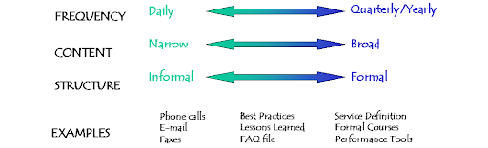  
*Figure 1: Examples of formal and informal reports as they relate to frequency and   
content of the communication.*

The easiest approach to writing on the job is to recognize that there are many situations which we can think of as typical, repeatable, standard. These situations do not call for great originality or deep thought. They require an understanding of the form or convention used in a particular situation. Some examples:

* A progress report
* A job description
* A job procedure
* A problem-resolution memo
* An option memo
* A trip report
* An analytical comparison
* A hazard alert
* A strategic plan
* A feasibility report
* A procedure

# Find A Format and Make it Visible

A report is an essential form of corporate communication that helps other people, managers and co-workers, stay informed, review opinions, plan for the future, and make decisions. Reports are permanent records of operations at every level of an organization, providing accounts of incidents, events, actions taken, decisions made, results achieved, standards and policies met with, and interactions with employees, stakeholders, and the public.

Written with clear objectives in mind and designed for specific audiences, reports are based on reliable facts and evidence, always separating verifiable fact from opinion and substantiating any opinion that is expressed. Because they are legal documents that can be used as evidence in court, they must be accurate, complete, and objective, weighing both sides of an issue and demonstrating careful attention to detail.

## Factors in Successful Reports

The quality of a report and its effectiveness depend on the writer’s control: content, clarity, and skim-ability.

### Content

1. Write with your aims, objectives, and main message in mind.
2. Weigh information according to what is going to be done with the report and what its future use will be.
3. Include information the reader needs for action-taking and decision-making.
4. Include pertinent facts so that they make sense to readers and relate clearly to the problem you are solving, the question you are answering, and the conclusions that you draw. Never manipulate facts to arrive at a predetermined conclusion.
5. Take readers’ needs into account when selecting information and consider the background information readers may or may not already have.
6. Help readers understand by organizing information in a logical way.

### Clarity

1. Apply principles of good English; write in simple, straightforward, tightly constructed sentences with correct grammar, punctuation, and spelling.
2. Use text citations selectively.
3. Include visual elements that are explanatory, show significance of facts, match your objectives, and help the reader make an informed decision; introduce and label each visual you use.
4. Ensure facts are introduced in the right place by editing your draft and deleting extraneous material.
5. Use consistent evaluation criteria when you weigh options and draw conclusions.

### Skim-ability

1. Select a readable font to reduce eye strain and lessen reading time
2. Use informative headings and lists to group similar data together, signpost significant facts, emphasize the main ideas, and show where they are leading.
3. Use white or neutral space effectively.

## Use a Visual Layout to Help the Eye of the Reader

Your job as a writer is to get your views across:

1. **Clearly**: you want your readers to grasp exactly what you mean.
2. **Briefly**: you want to please your readers by saving their time and energy.
3. **Persuasively**: you want to make your ideas stick.

Remember that your tone of voice, your choice of words, and your understanding of audience can make a difference. To be a powerful writer, use principles of visual layout. Effective visual presentation plays a vital role in the way formal reports communicate information to readers by lending credibility and interest.

As you plan what you are going to write and as you write, ask yourself, “how can I lay this material out so that my reader can see quickly, easily, and precisely what is important? Are there paths for the reader? Can the reader scan the document and find meaning quickly?

For typed texts you can draw on spacing, capitalizing, underlining, numbers, letters, typefaces, colors, and other design devices. You can use the following for a variety of layouts:

* Paragraphs
* Sections
* Headings
* Graphs
* Tables
* Problem-solution formats
* Flow charts
* Representational drawings
* Lists, outlines, check-offs
* Computer graphic designs

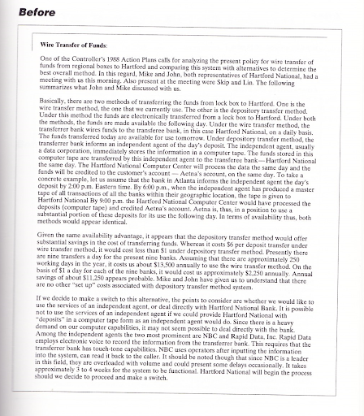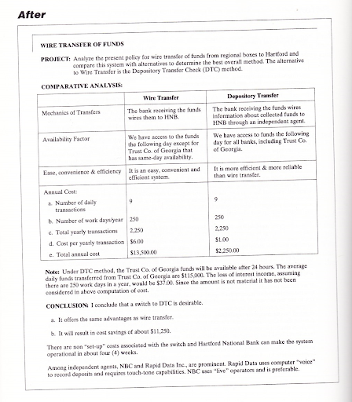

*Figure 2: Compare the Before and After version of the document.   
Which one would be easier to skim or read?*

# Report Structure

Reports start with a summary, establish the context, follow with the body, and end with a conclusion or next step. Like a story,

* **Summary**: the condensed version of events.
* **Context**: how the document came to be written; provides context.
* **Details**: all the relevant facts and findings of the case.
* **Conclusion** (next step): what happens next

## Summary

Summaries are generally written last and read first. The summary is a condensed version of the report, containing the main ideas of the report and reflecting the emphases of the report.

## Context

The context section is often referred to as the background (called introduction in long reports) and it establishes audience and purpose. A report has to make sense even to readers not already familiar with how the report came to be written.

## Details

The details section is the core of the report, fulfilling its purpose.

## Conclusion

A report does not just report information. It is a change agent that provides information used in decision making and

## Paragraphs

Paragraphs should be short, to the point, simple, and unadorned. Create clarity by breaking complex information into small, clear, easily digested paragraphs. Use the following guidelines to construct effective paragraphs:

* Keep paragraphs short. (seven lines on average; if more than ten lines, you are trying to do too much, consider breaking into two)
* Begin paragraphs with a topic sentence.
* Make paragraphs unified. (contains only details relevant to the central idea introduced by the topic sentence)
* Make paragraphs complete. (present all information the reader needs to understand the idea developed in the paragraph)
* Make paragraphs cohesive. (provide clear logical connections among sentences and ideas)

short dash